2022 – NON PRODUCTION of LICENCE
ROAD RACE, DRAG, SPRINT, HILL CLIMB, SUPERMOTO

Auto-Cycle Union Ltd, ACU House, Wood Street, Rugby, Warwickshire CV21 2YX
Tel: 01788 566400 Fax: 01788 573585 E-mail: admin@acu.org.uk

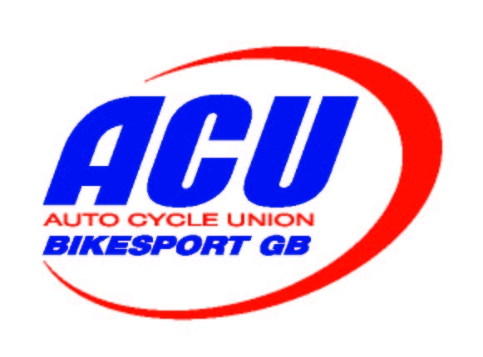

Organising Club

Event Date

Venue Permit No:

Status of Event

As the official in charge of Scrutinising licences for the above event I declare that all Entrants and Drivers have produced for inspection Competition Licences of the appropriate grade and valid date with the exceptions stated below and that no other person has been approved or participation in this event. In respect of the exceptions the appropriate fine has been paid and if forwarded herewith. (Minimum Fine £5.00, Maximum Fine £10.00 - Cheques payable to; ACU Benevolent Fund)

This form together the any fees paid must be passed to the ACU Steward of the Meeting, to be forwarded direct to the ACU.

Declaration

I declare that at today’s date I am the holder of a Competition Licence of the appropriate grade and a valid date issued to myself, by the ACU, which, if I had produced for inspection, would have enabled me to take part in this meeting. In consideration of being permitted to take part in this meeting despite failing to produce my Competition Licence I have paid the appropriate fine as stated herewith.

Name | Licence No. | Date of Birth | Postcode | Signature | Fine paid

ACU Steward (Name)

FORM RR3/2022

